International Leadership Association
Women and Leadership Member Community (W&L)
2021 Strategic Plan

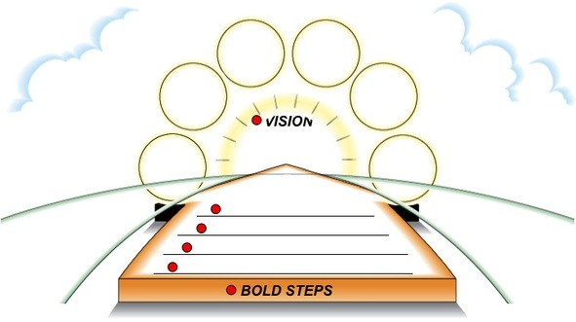

Introduction and Background
The Women and Leadership Membership Community (W&L) celebrated its 10th Anniversary in 2020. Beginning in 2010 when three ILA members organized a “Women in Leadership Network Luncheon” at ILA’s annual conference, W&L now has over one thousand members. W&L officially established is charter, structure, and website in 2011 and drafted its foundational document, “The Asilomar Declaration and Call to Action on Women’s Leadership” at the W&L conferences in 2013 and 2015 at the Asilomar Conference Center in Pacific Grove, California. The document represents the collective expertise of the scholars and practitioners who attended the conferences, most of whom continue to actively participate in the work of W&L. The Declaration and Call, which remains as the inspiration behind the work of W&L identified five focus areas: 1. Increasing Equality in Power and Decision-Making; 2. Helping Girls and Young Women Become Leaders; 3. Expanding Leadership Education and Development Worldwide; 4. Advancing Women in Leadership; 5. Identifying Critical Areas for Future Research. The W&L is led by an Executive Leadership Team (ELT) comprised of 14 members who are elected for three-year terms, and that includes a President, President-elect, and past President who serve one-year terms. Elections are held annually
The call to identify areas for additional research on women’s leadership was furthered in 2014 through a research colloquium held at Utah Valley University. The colloquium was not sponsored by ILA but independently by several of the leaders who had initiated W&L who obtained a grant. The colloquium addressed theory development and was intended not only to build theory development skills but also to stimulate theoretical scholarly research. The 70 participants identified their areas of interest among five theory areas: Leader Identity, Leadership Purpose and/or Calling, Second-Generation Gender Bias, Power, and Intersectionalities. They formed research teams, some of which continue to collaborate on research and publications today.

The W&L has held five conferences since its inception. The names of the conferences trace the progression of the W&L’s leadership focus: “Building, Bridging, and Blazing Pathways for Women and Leadership: Celebrating the Past, Present, and Future” (2013); “Advancing Women in Leadership: Waves of Possibilities” (2015); “Advancing Women in Leadership: Cultivating Our Whole Selves” (2017); “Building Solutions, Harmony, and the Greater Good” (2019); and “Leading Differently: Capacity Building Knowledge Sharing, Intergenerational Networking” (2020).

The W&L made an agreement with the ILA to host a conference, colloquium, or other smaller event annually. The conferences would be held on even-numbered years and the smaller event would be held on odd-numbered years. Consequently, the W&L is planning a research colloquium in June 2021, to be held in Canada or virtually, depending on the COVID-19 pandemic.

In addition, W&L has published a series of seven volumes on key issues in women’s leadership, which have made a significant impact on furthering women’s leadership globally. Further, W&L initiated four awards to members who had a significant impact locally and globally.

During 2020, W&L Chair Chrys Egan developed W&L By-Laws by updating the original W&L Charter. These By-Laws were approved by the ELC.

Strategic Planning Process

Under the leadership of former W&L Chair, Denise Thomson, W&L decided it was time to take stock of to where the community had arrived and to begin to plan strategically how to maximize the community’s “sweet spot” and take bold steps forward to increase our ILA footprint, our global reach, and our impact on women’s leadership writ large. The process began in 2019 at the W&L conference at 1440 Multiversity near Santa Cruz, California. Denise facilitated a World Café at which W&L Executive Leadership Team (ELT) members exercised both right and left brain sensibilities and discussed questions such as what brought them to W&L, what was special about W&L, and what was worth keeping. Denise maintained the process through online gatherings of ELT members in August and September of 2020 in which the ELT discussed a number of strategic steps forward.

Current Chair Chrys Egan and Chair-Elect Randal Joy Thompson took the reins from Denise in late 2020 and worked together to draft this strategic plan. The plan is based upon what W&L ELT members discussed over this 2019 to 2020 period. Denise initiated the process by posing the question “What is W&L’s ‘sweet spot,’ and what makes W&L different from other member communities?” A preliminary answer to this question provided by Denise and a catalyst for the strategic planning process is that W&L members share a passion for women and leadership, whether academics, practitioners, or as “pracademics”; members bring a great diversity of expertise, interests, and thought; and conferences are small and in retreat-like settings that encourage personal growth and developing relationships.

Strategic Plan

This strategic plan represents the “bold steps” the ELT with the help of the W&L intend to take during 2021 to help achieve our vision. We begin by remembering our original inspiration taken from the Asilomar Declaration and confirming our intention to support ILA’s 2020 Positioning Plan.

Original Inspiration: W&L “is a network of leadership scholars and practitioners who work together to enhance their knowledge, expertise, and research in the area of women and leadership and to advance the standing of women in leadership” (Asilomar Declaration 2015).
Support ILA 2020 Strategic Positioning Plan Positioning Core Areas (PCA)
- Relationship development to grow the field of leadership and the ILA
- Membership development to expand, engage, and diversify our membership
- Program development to assess, refine, and enhance our program portfolio
- Resource development to strengthen financial sustainability and organizational capacity

The ELT will review our mission, the vision we are working to achieve, our values, and the assumptions upon which this 2021 plan is based.
Mission: To advance the standing of women in leadership globally through research, leadership development/coaching programs, mentorship, consultancy, knowledge sharing, networking, activism, and outreach.
Vision: A global community of leadership scholars and practitioners internationally recognized as being an outstanding and significant ILA member community and on the cutting edge of research and practice regarding women’s leadership.
Values:
- Asilomar Declaration continues to inspire and drive the work of W&L community
- W&L continues to support the UN Sustainable Development Goals (SDGs) involving women
- Leadership, scholarship, and practice are equally valued
- We are committed to diverse, inter-generational, and global membership
- We uphold the highest standards of academic research and ethical practice
- Activism is an essential component of advancing women’s leadership
Assumptions:
- ILA will support W&L’s Strategic Plan
- ELT members will support the plan and take the lead in facilitating its realization
- W&L members will be willing to lead bold steps and will follow through with intended goals
- ILA and W&L will continue to develop a strong collaborative relationship with transparent communication
- ILA will provide W&L with sufficient funds to implement strategic plan, where necessary
Bold Steps in 2021:
In order to support ILA’s and W&L’s membership development, relational development, global reach, and vision of being a globally recognized community, we will:
- Conduct a global imaging, marketing, and membership outreach campaign
- Determine whether to change our name to Gender and Leadership Community to recognize individuals who do not identify as “women” and therefore to broaden our membership to be more inclusive.
- Design a W&L Logo and unique community “look.”
- Send marketing material soliciting members to all leadership programs and women’s studies programs in the around the world.
- Organize a marketing team of women from each region to identify leadership programs.
- Reach out to other key women’s groups for collaborative opportunities.
- Develop new member orientation and tool kit. Use the phrase “We do this through (fill in the blank)” as a way to capture community processes and priorities.
- Conduct a survey of W&L members and another survey of all ILA members regarding what they want from W&L, what they can offer, and what would induce them to join/stay.
- Conduct a survey of people who attend one W&L conference and never return to determine what are the main reasons for not returning.
- Reach out to women in ILA’s other Member Communities for co-planning, co-hosting events, programs, sessions.
- Develop an “activism” plan as part of the marketing plan.
In order to support our members in various career stages (emerging, highly experienced, transitioning, etc.) and to establish W&L as on the cutting edge of women’s leadership practice, we will:
- Design, Advertise, and Implement a Mentorship Program:
For younger/less experienced leaders
- Identify W&L members willing to serve as mentors for younger/less experienced leaders
- Develop standards and process of mentoring
- Advertise globally for mentees
- Develop feedback form/survey for mentees
- Implement mentorship program
For experienced or transitioning leaders
Design, Advertise, and Implement Mastermind groups for women in various leadership sectors:
- Identify the key sectors W&L women work in
- Design group structure and process and standards
- Advertise among W&L members
- Develop feedback form for members
- Implement groups
- Develop feedback mechanism whereby ideas from groups are fed into W&L and ILA
In order to achieve our vision as leaders on the cutting edge of research about women’s leadership, we will:
- Support Research Partnerships and Publishing Opportunities

Plan and host 2021 Research Colloquium:

- Identify journal special issue
- Identify other publishing venues
- Host webinars for future researchers
Begin follow-on W&L Leadership book series:
  - Identify topics of books, editors, number of books
  - Identify publisher
  - Initiate series
Continue to support our writers’ group:
a. Invite members to participate
b. Share publication opportunities
c. Support members through the publication process

In order to share our knowledge and build on our expertise on women’s leadership, we will:
- Continue to support and promote I-WIN monthly leadership group
  - Develop and share the schedule of meetings for 2021
  - Invite and coordinate presenters
  - Record and disseminate presentations to ILA and other groups
In order to achieve our vision, we will continue our involvement in the ILA Global and W&L Conferences.
- Plan 2021 W&L Contribution to ILA Global Conference in Geneva and 2021 W&L Conference

ILA Global Conference in Geneva
a. Host a Welcome Orientation on day one
b. Continue hosting our “luncheon,” but in a revised format or alternate event based on member feedback such as: lower cost and higher interaction Luncheon, Wine and Cheese, Dessert and Coffee, or Drinks and Dessert
c. Identify award winners and host Award Winner Recognition at the above event
d. Host our Business Meeting (with light fare)
e. Review and organize our W&L presentation sessions

Plan 2022 W&L Conference
- Identify Conference Chairs and Program Chairs
- Identify location and financial contributions
- Obtain ILA agreement
In order to support ILA’s intent to increase financial viability:
- Financial Strategy (These are only proposals which would require ILA approval.)
  - Design and sell W&L merchandise or other mementos
  - “Sell” coaching programs
  - Charge for trainings such as in “ethical leadership”
  - Create and market a Speaker’s Bureau

In order to build more and stronger relationships that highlight activities and W&L member accomplishments, develop:
- Develop Internal and External Communication Plan
  - Meet with ILA to agree upon how we will work together and exactly what type of articles ILA will accept for publication in Interface and other ILA publications
  - Develop a 2021 calendar of articles for ILA Interface, W&L Facebook, Linked in, Twitter, Instagram, etc.
  - Draft agreements between W&L committees regarding how they will communicate, share information and strategies, and combine “forces” to accomplish the strategic bold steps of 2021

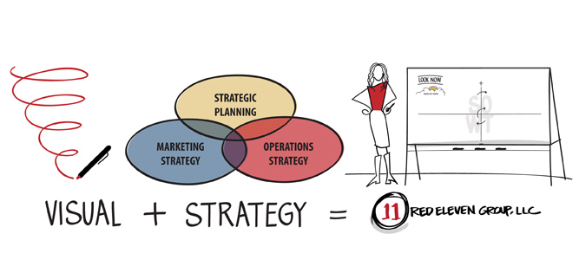

Our marketing strategy is included in our Strategic Plan. Our Operations Strategy is included in our By-Laws.

